**Database Technologies**

**UE19CS344**

**6th Semester, Academic Year 2021-22**

Week #9: An architecture for streaming data

(A5 - extra assignment)

Date: 1/4/2022

|  |  |  |
| --- | --- | --- |
| Name :  SUMUKH RAJU BHAT | SRN :  PES1UG19CS519 | Section :  H |

**Proposed Architecture:**

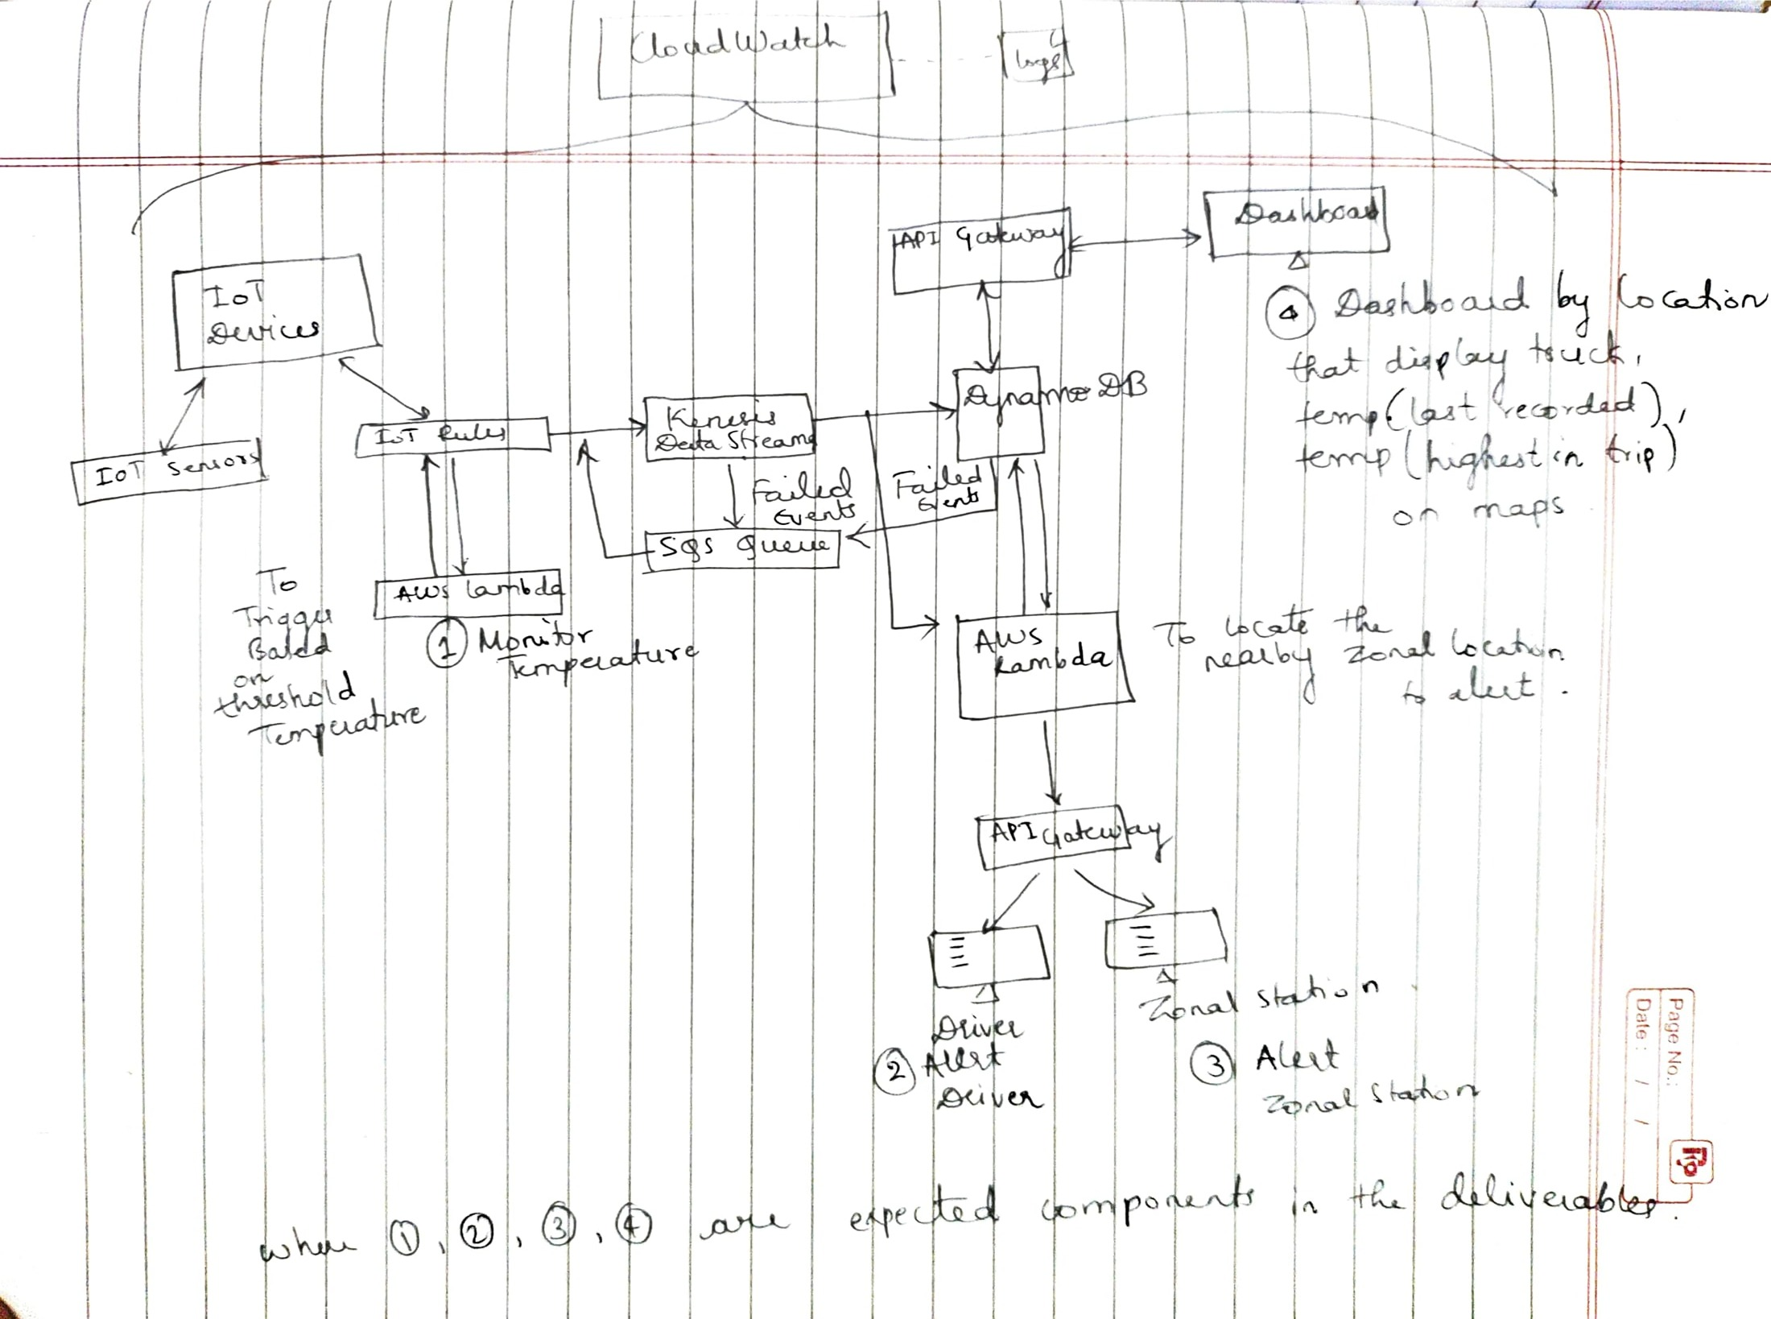

**Choice description:**

* AWS lambda: As it is event-driven computing platform which is used to check for temperature going above the set threshold and initiate further processing.
* Kenesis: It enables us to process and analyze real time data as it arrives and respond instantly instead of having to wait all your data is collected. It can handle any amount of streaming data and process data from hundreds of thousands of sources with very low latencies, that is, it provides high scalability. One of types of data, which is readily supported by it is IoT telemetry data, which is a bonus for the current application.
* API Gateway: For request/response handling to get/display input/results.
* SQS Queues: Failed processing data is put into the queue which needs to be put back to re-processing later. Using SQS, you can send, store, and receive messages between software components at any volume, without losing messages or requiring other services to be available at that exact time and also guarentees maximum throughput.
* CloudWatch: CloudWatch provides us with data and actionable insights to monitor your applications, respond to system-wide performance changes, and optimize resource utilization. CloudWatch collects monitoring and operational data in the form of logs, metrics, and events. You get a unified view of operational health and gain complete visibility of your AWS resources, applications, and services running on AWS and on-premises. You can use CloudWatch to detect anomalous behavior in your environments, set alarms, visualize logs and metrics side by side, take automated actions, troubleshoot issues, and discover insights to keep your applications running smoothly.
* DynamoDB: Key-value NoSQL database designed to run high-performance applications at any scale which in our application serves as a platform to store temperature data persistenly for future processing and analytics.